DINAKAR S

CH.EN.U4CYS21013

COGNIZNCE CLUB

TASK 7

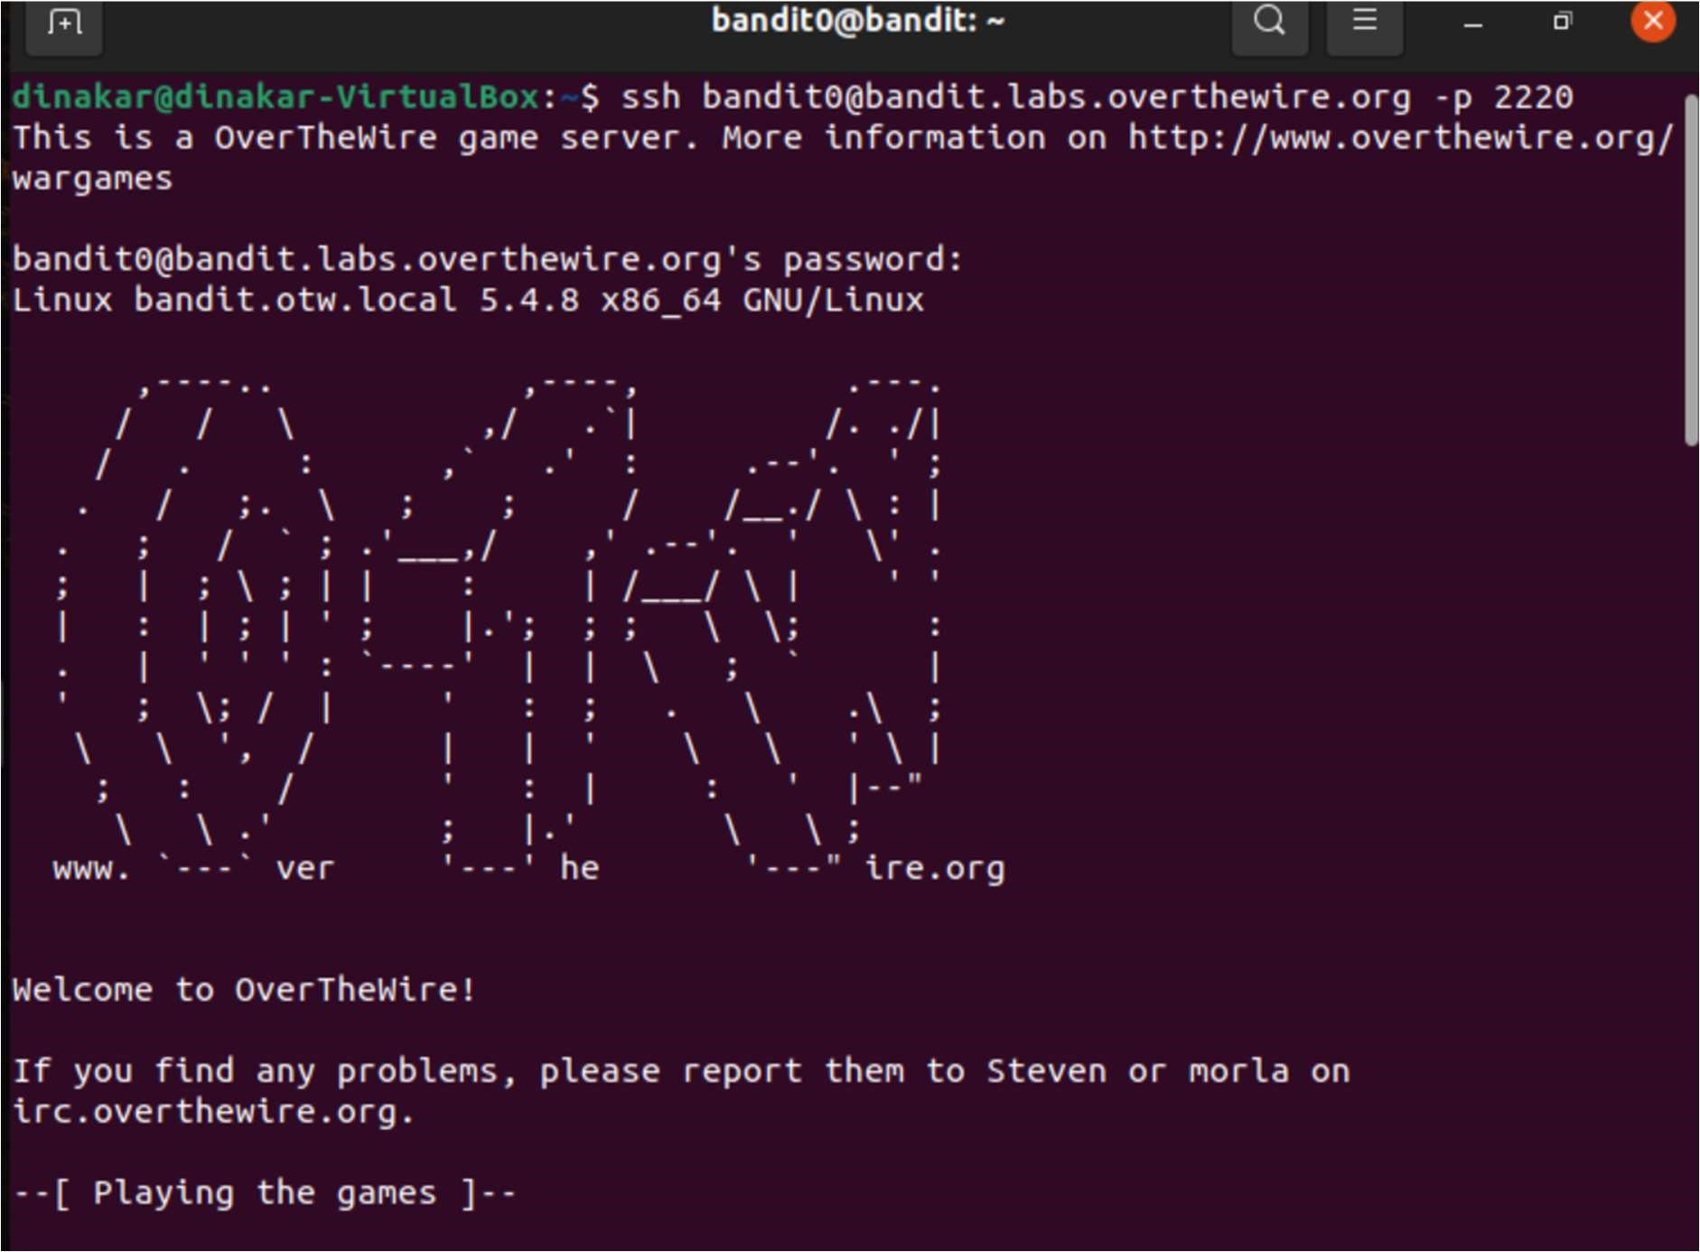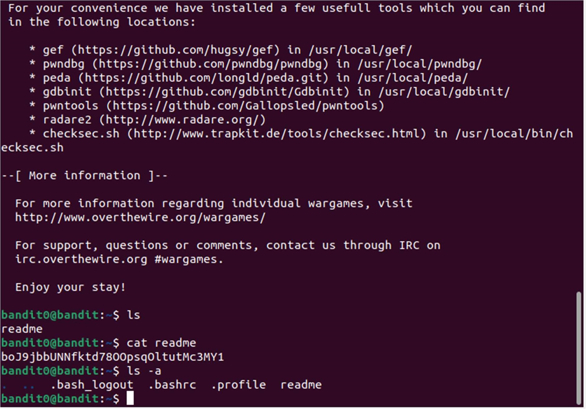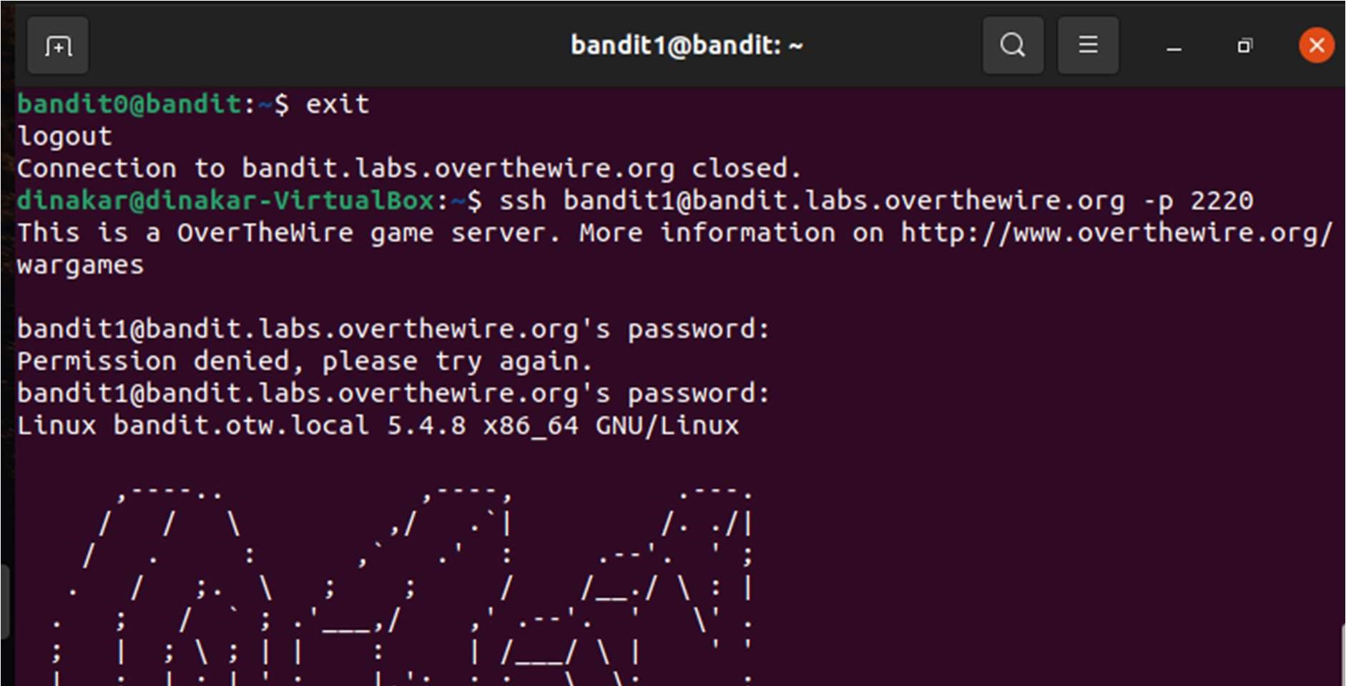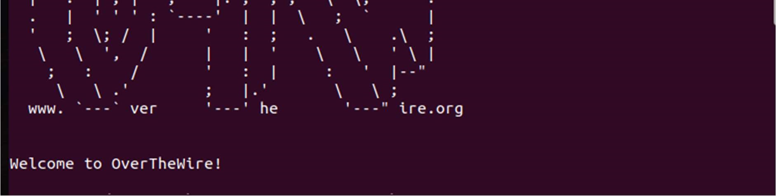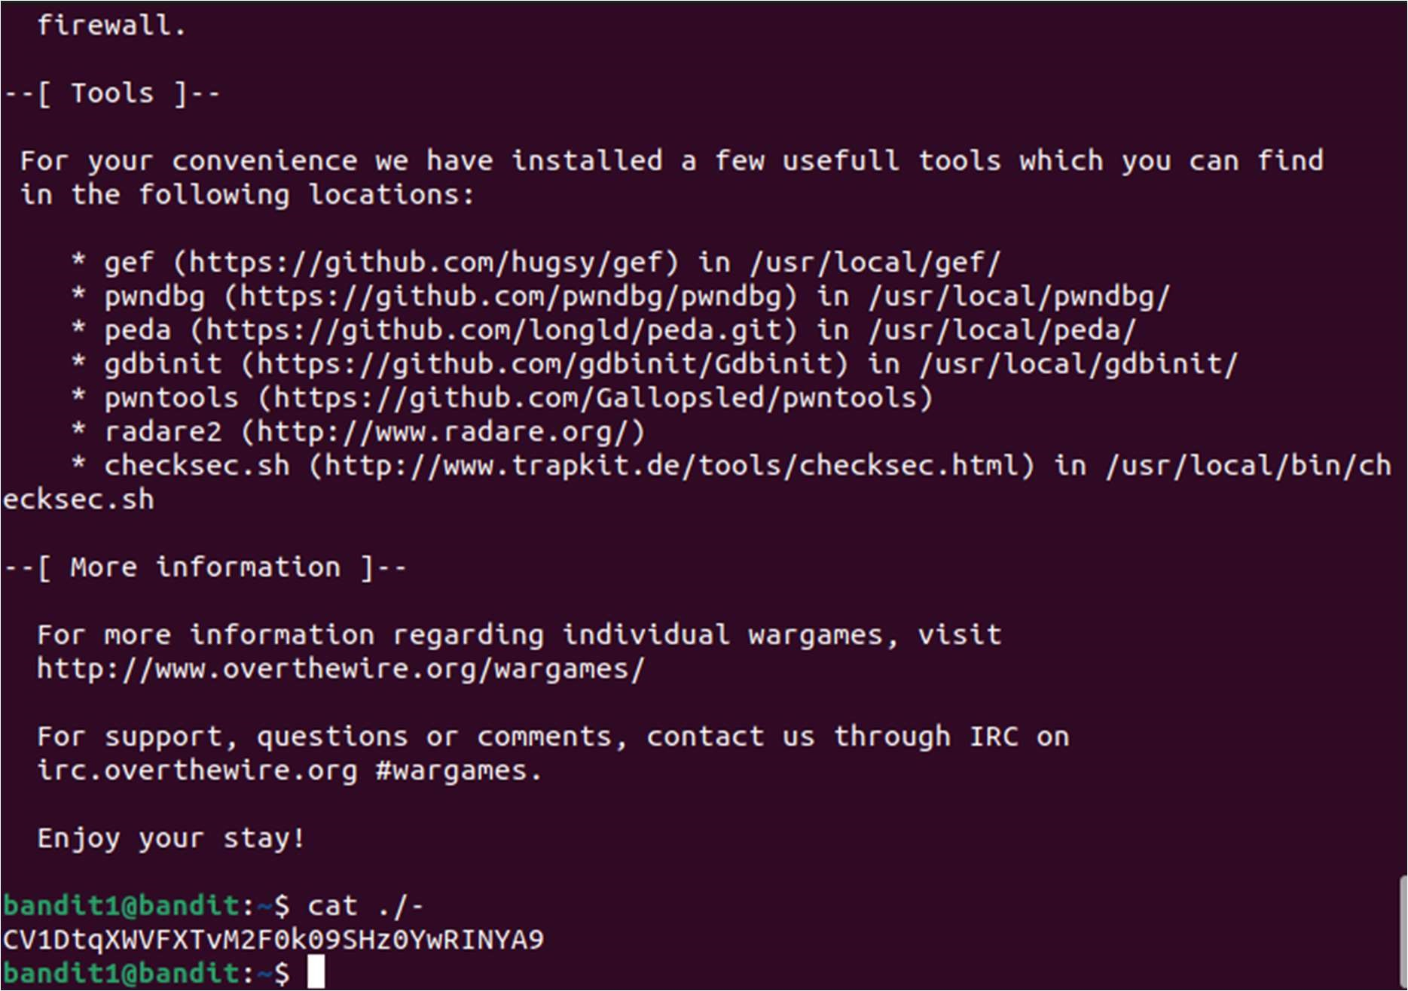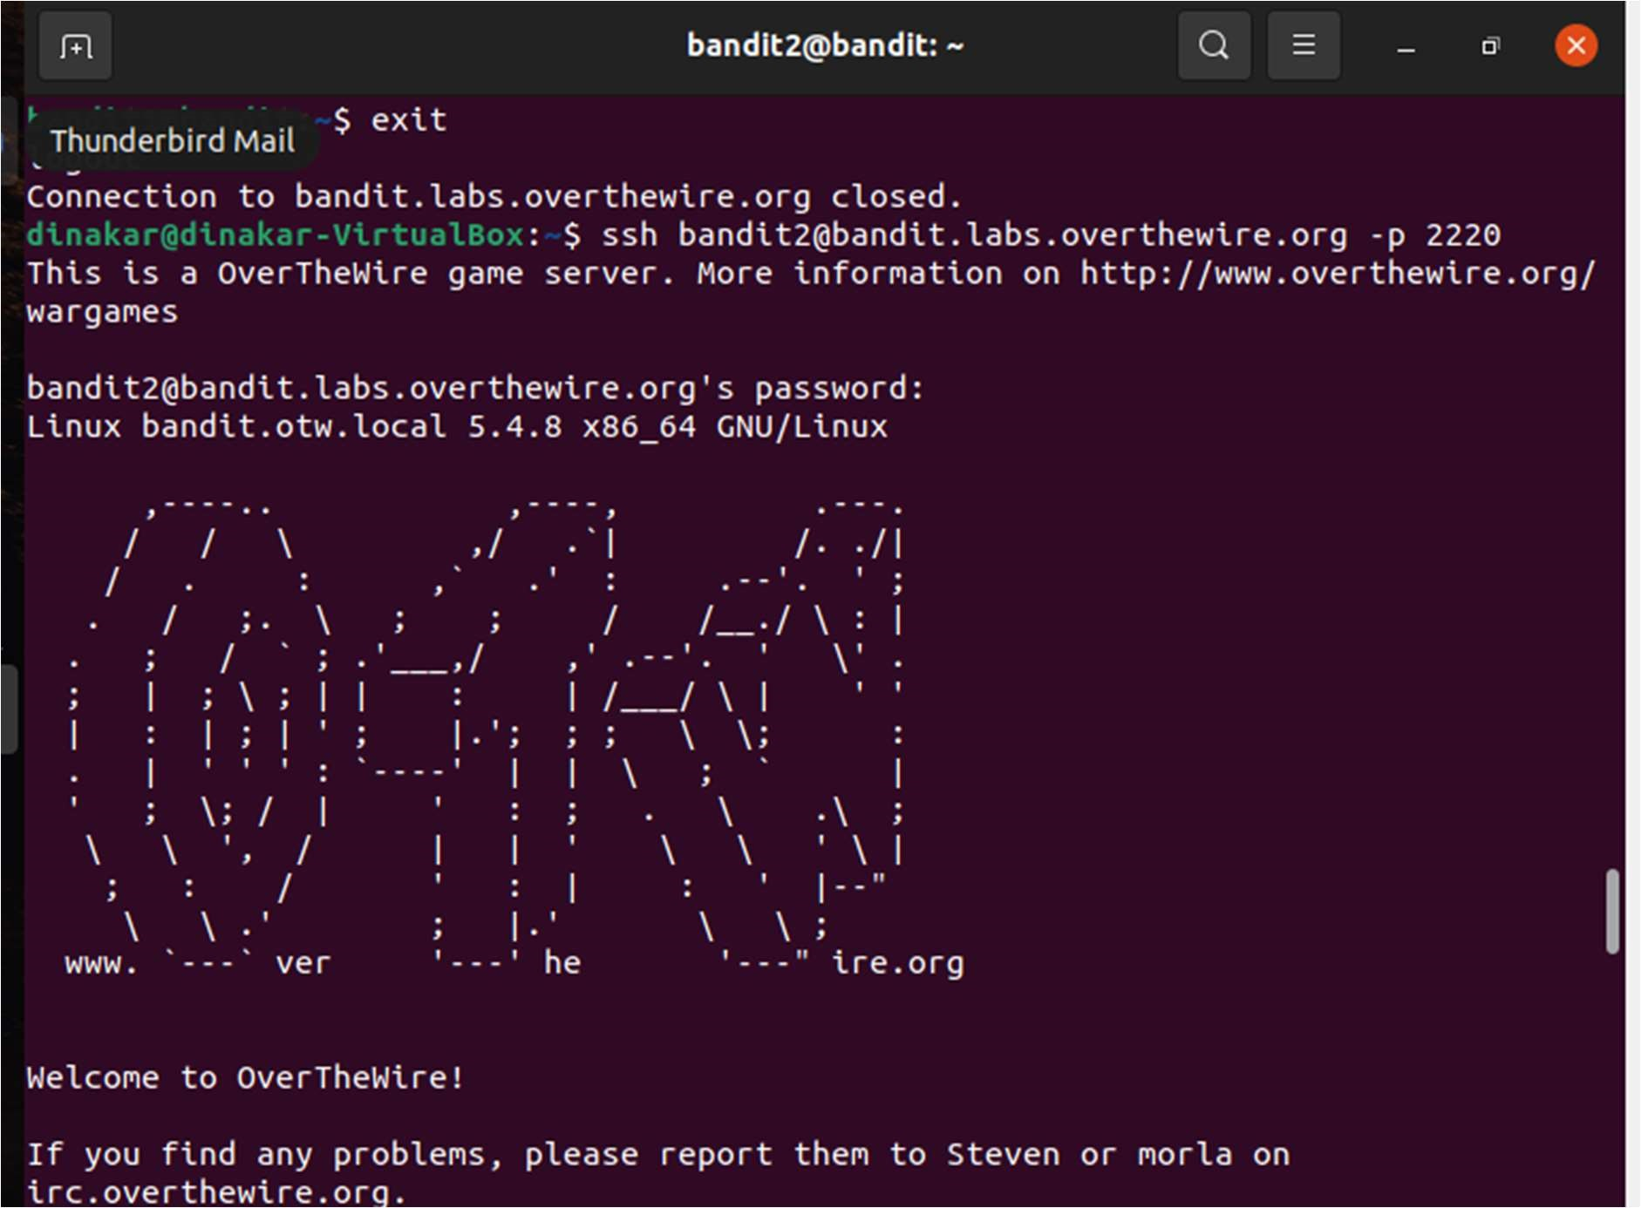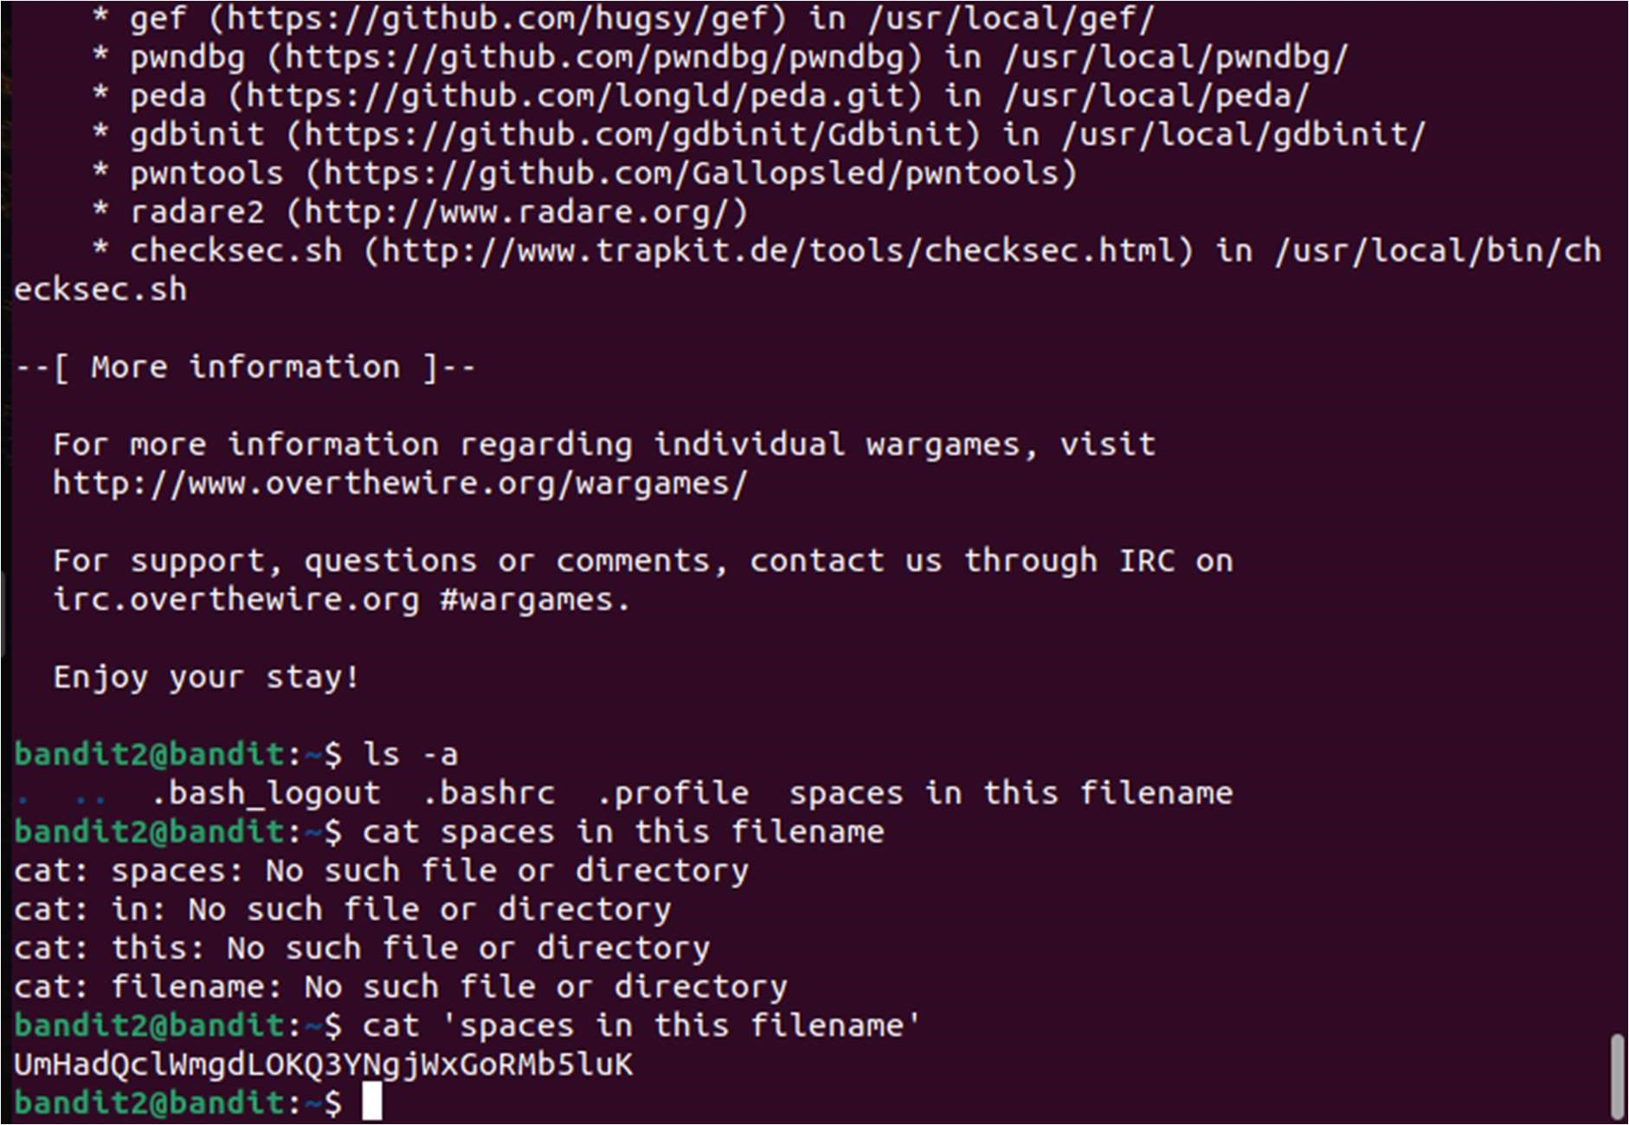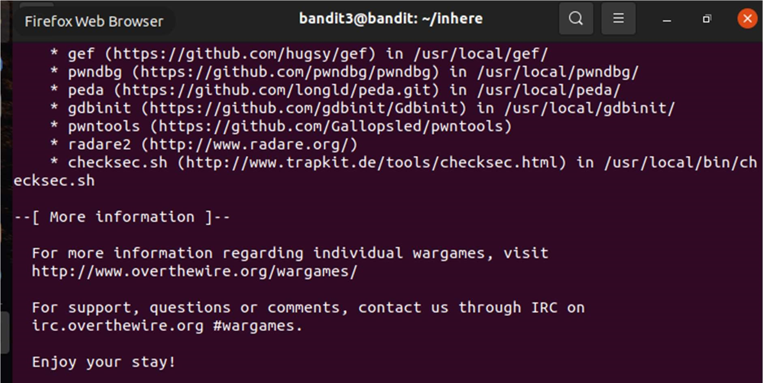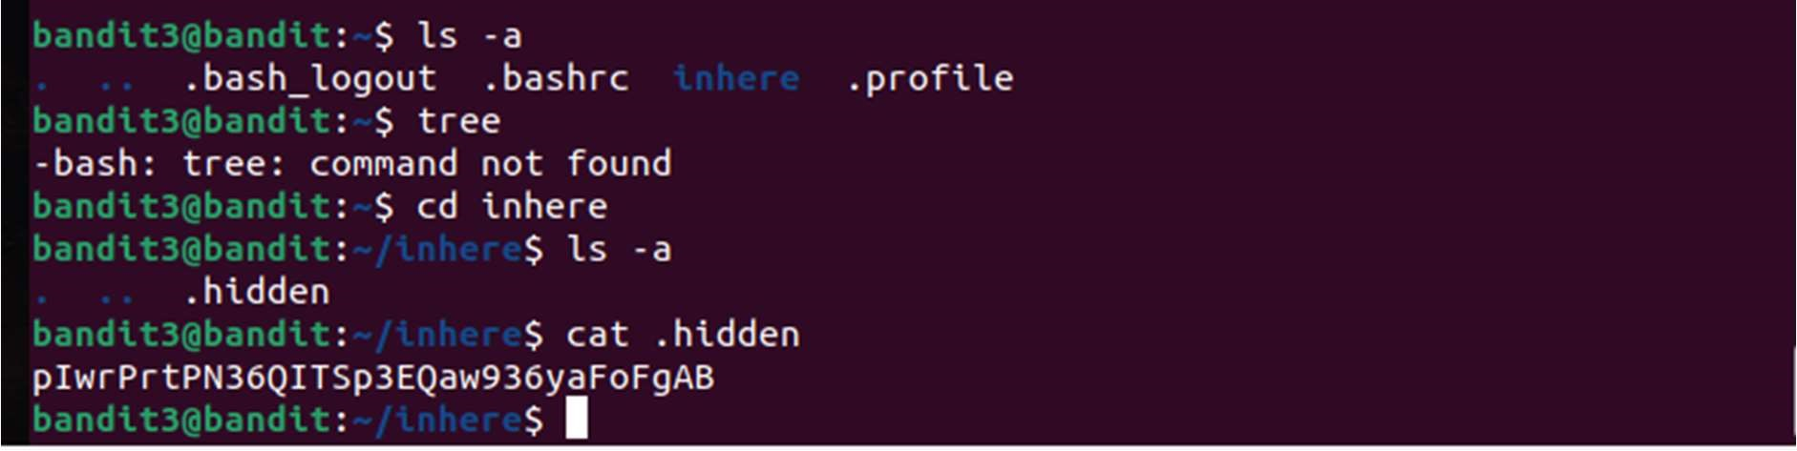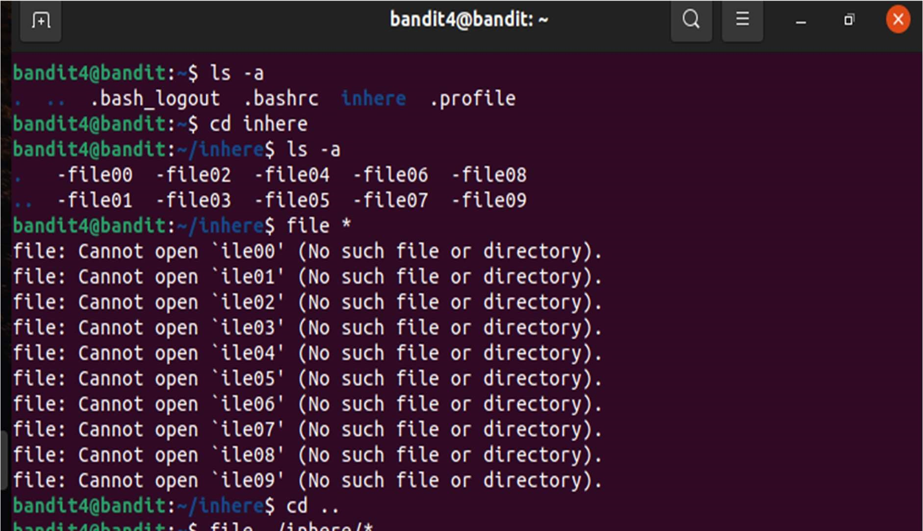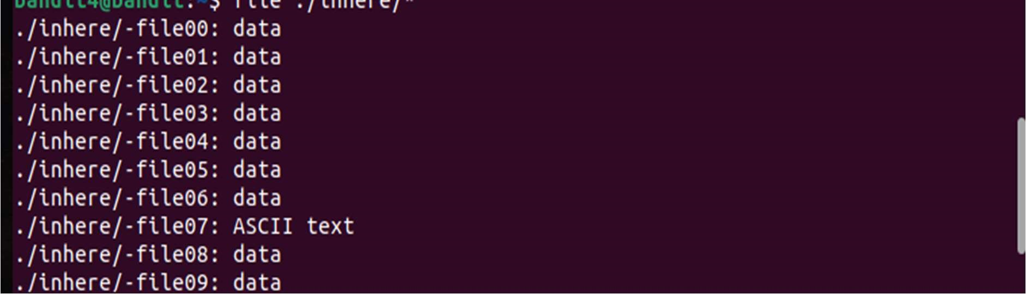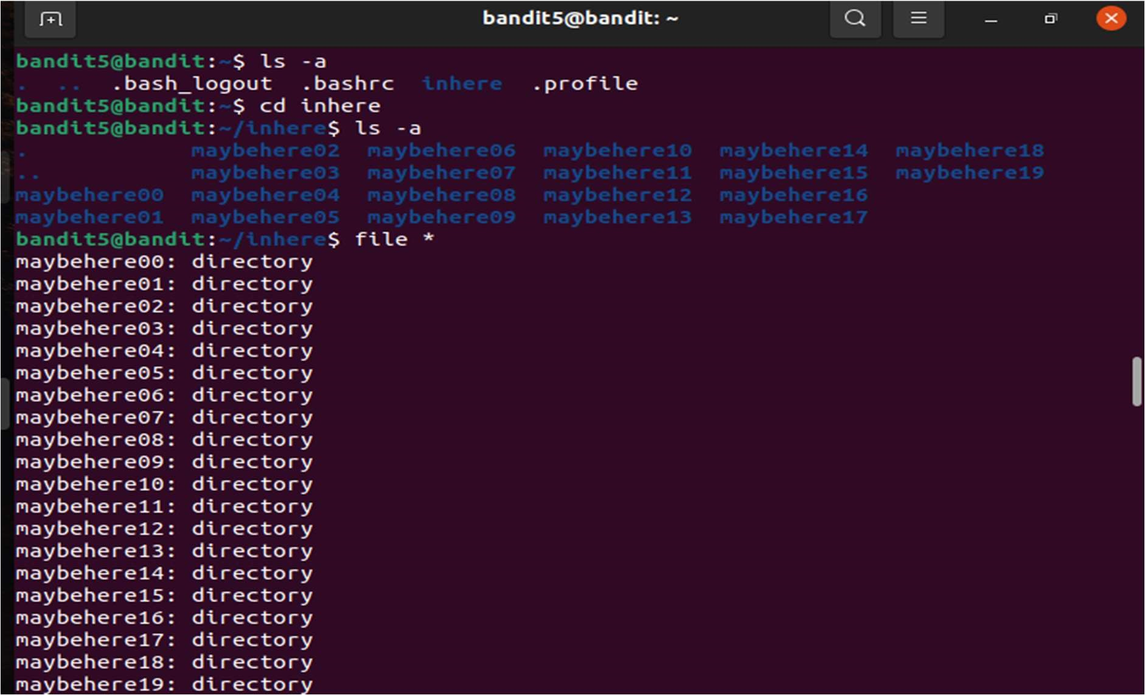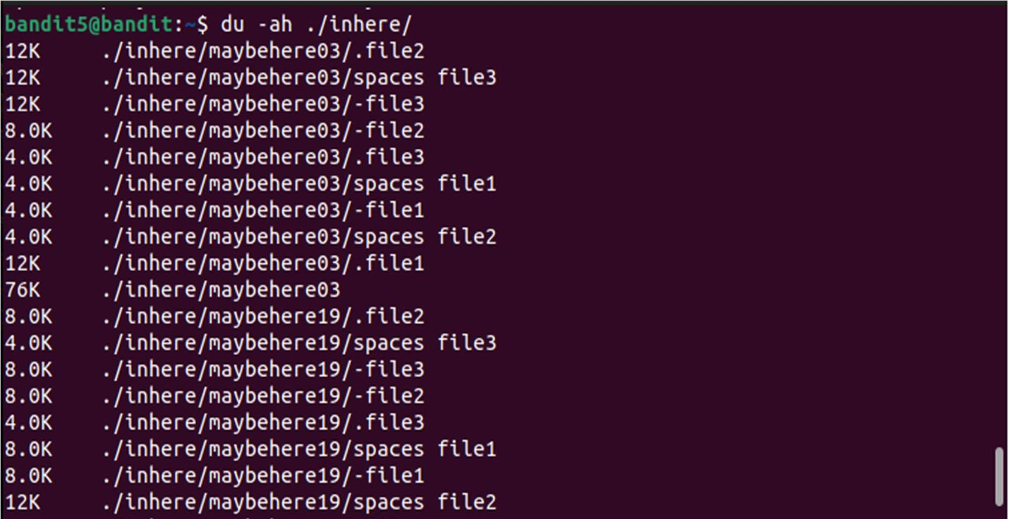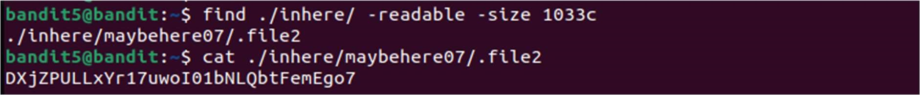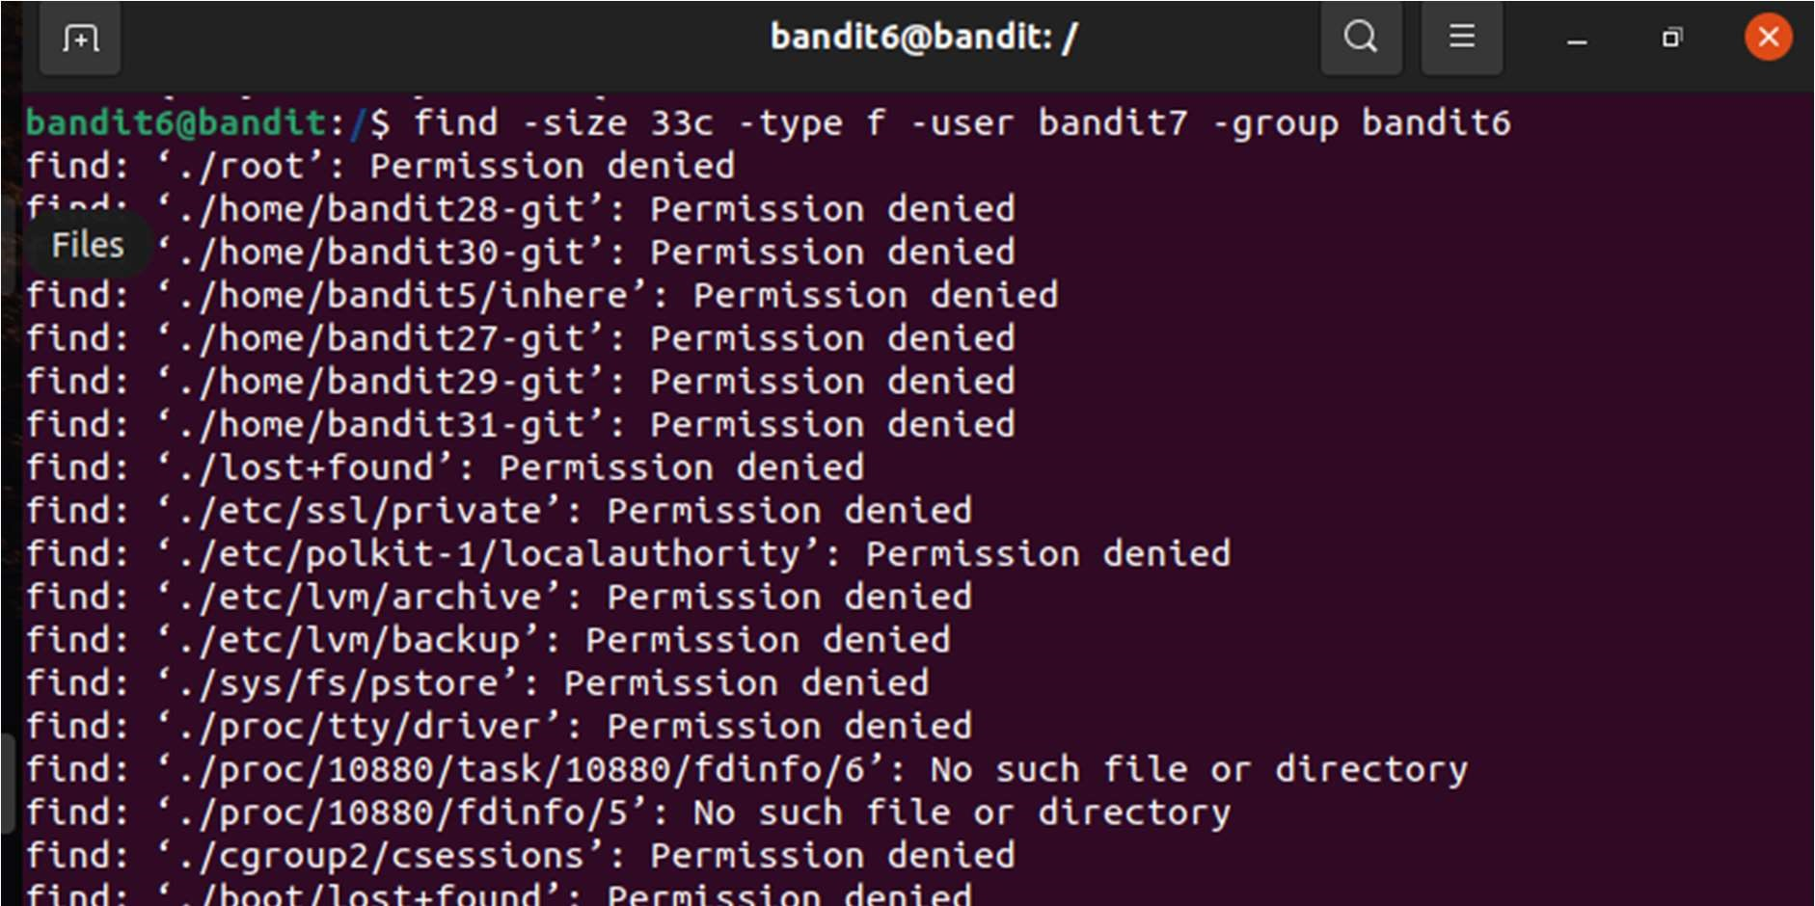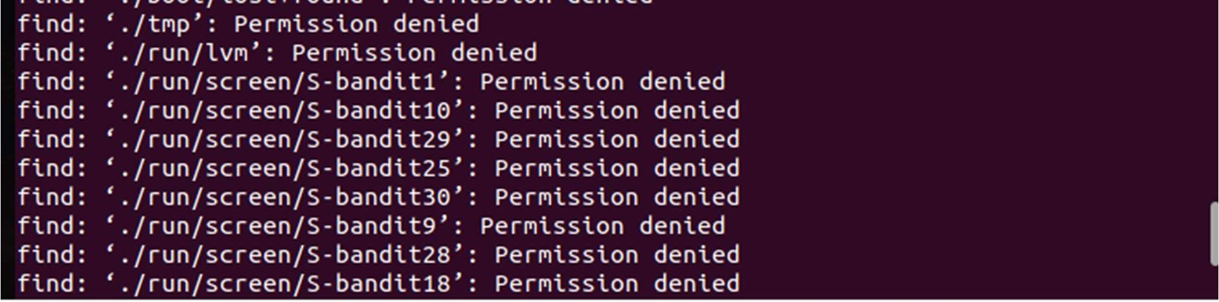

The file without “Permission denied “ is the file we’re looking for .

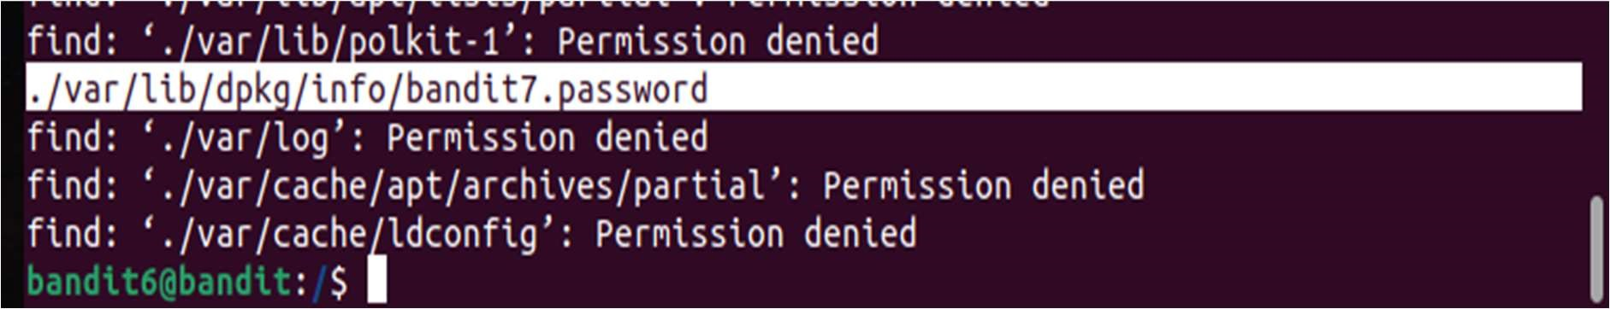



LEVEL 8

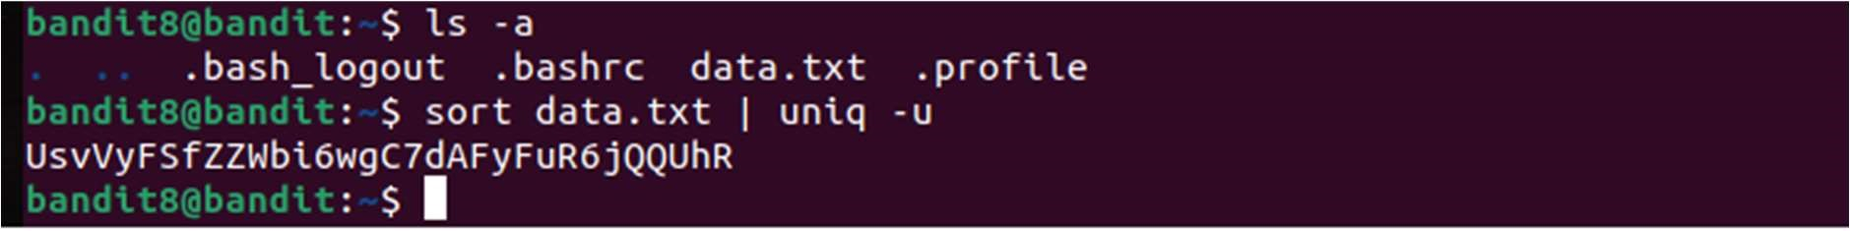

LEVEL 9

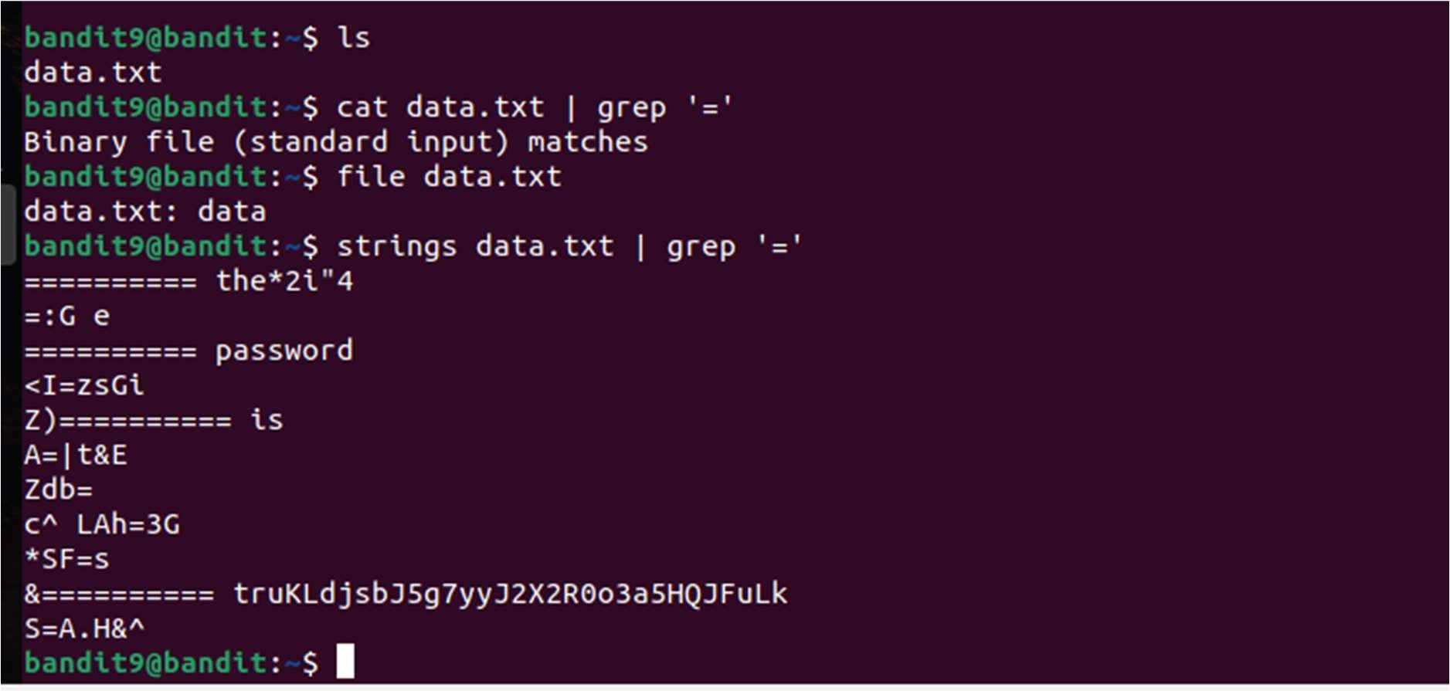

LEVEL 10

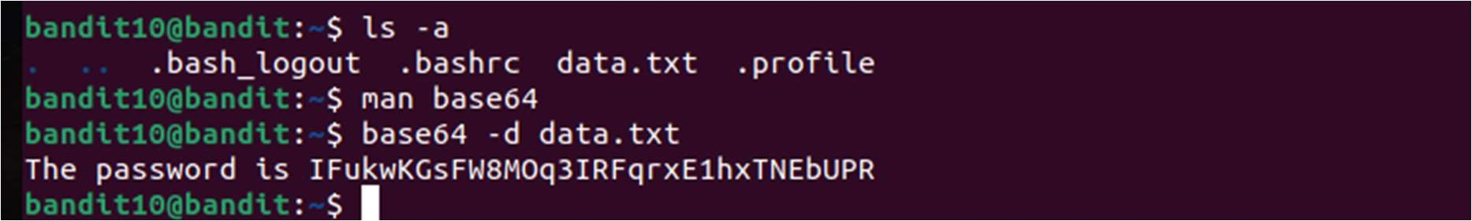

LEVEL 11

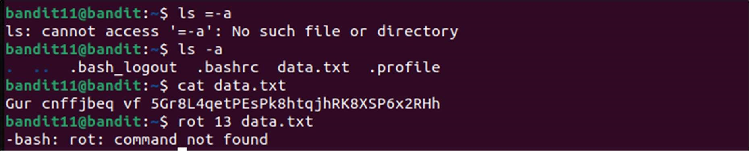

AS rot13 is not found

I used this website rot13.comto rotate letters by 13

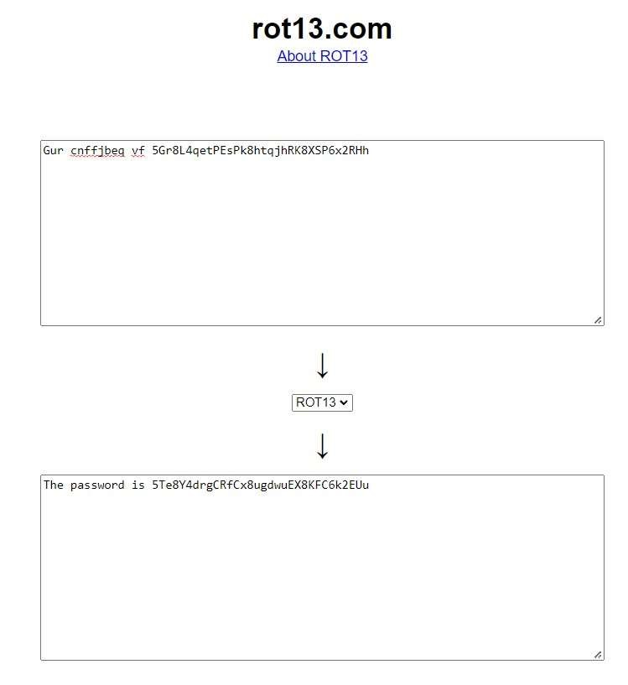

LEVEL 12

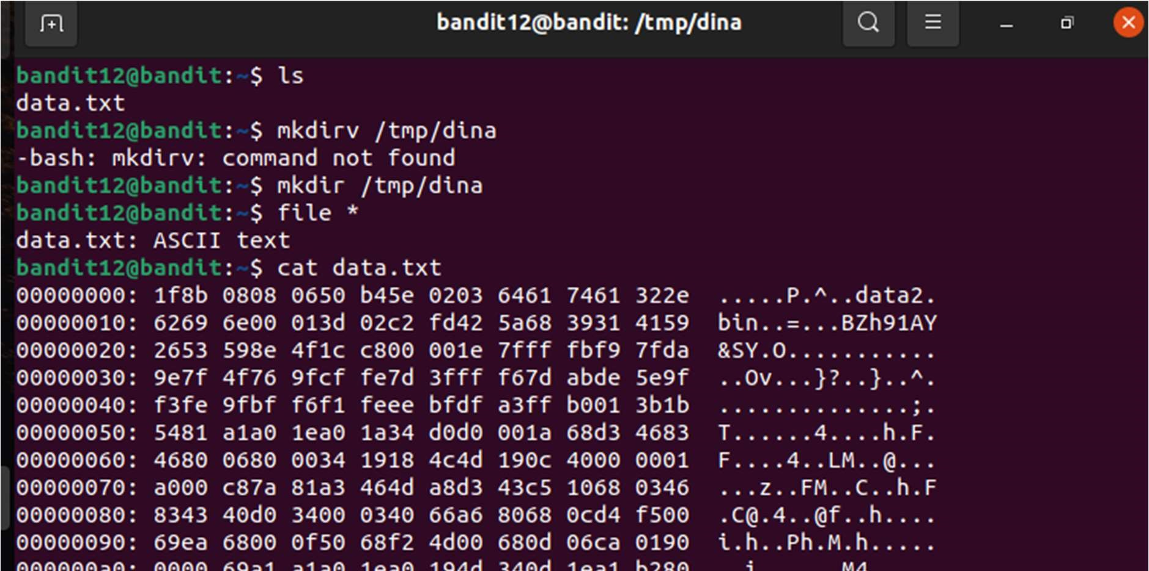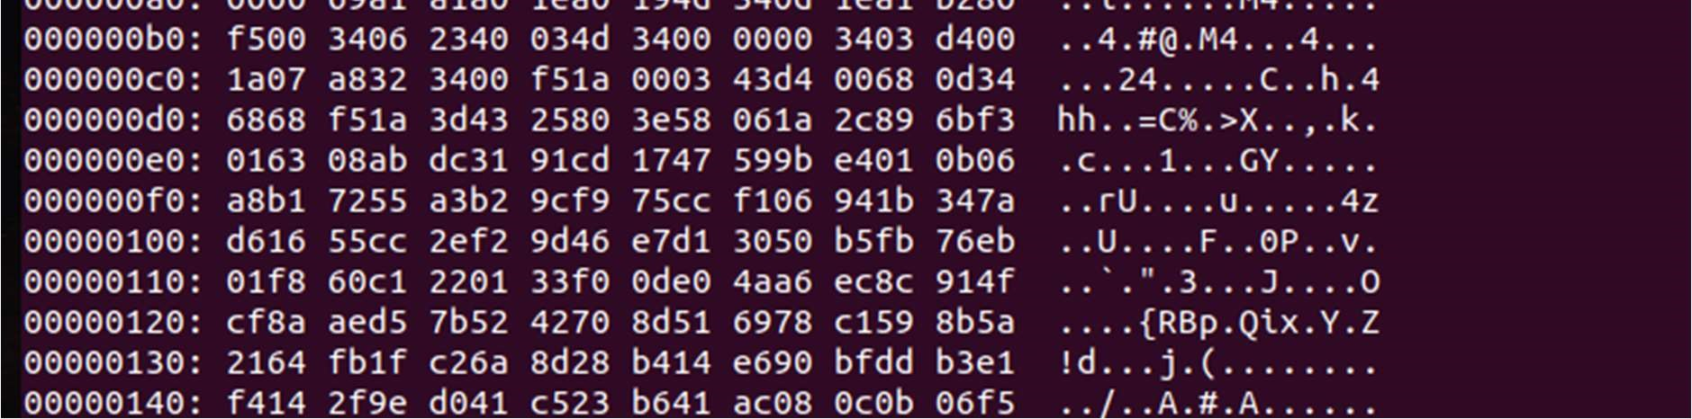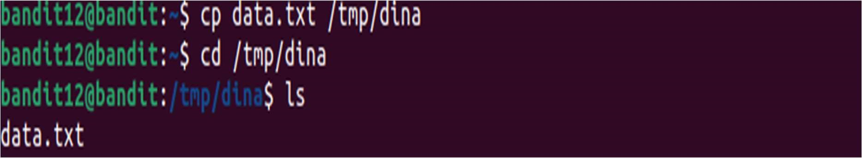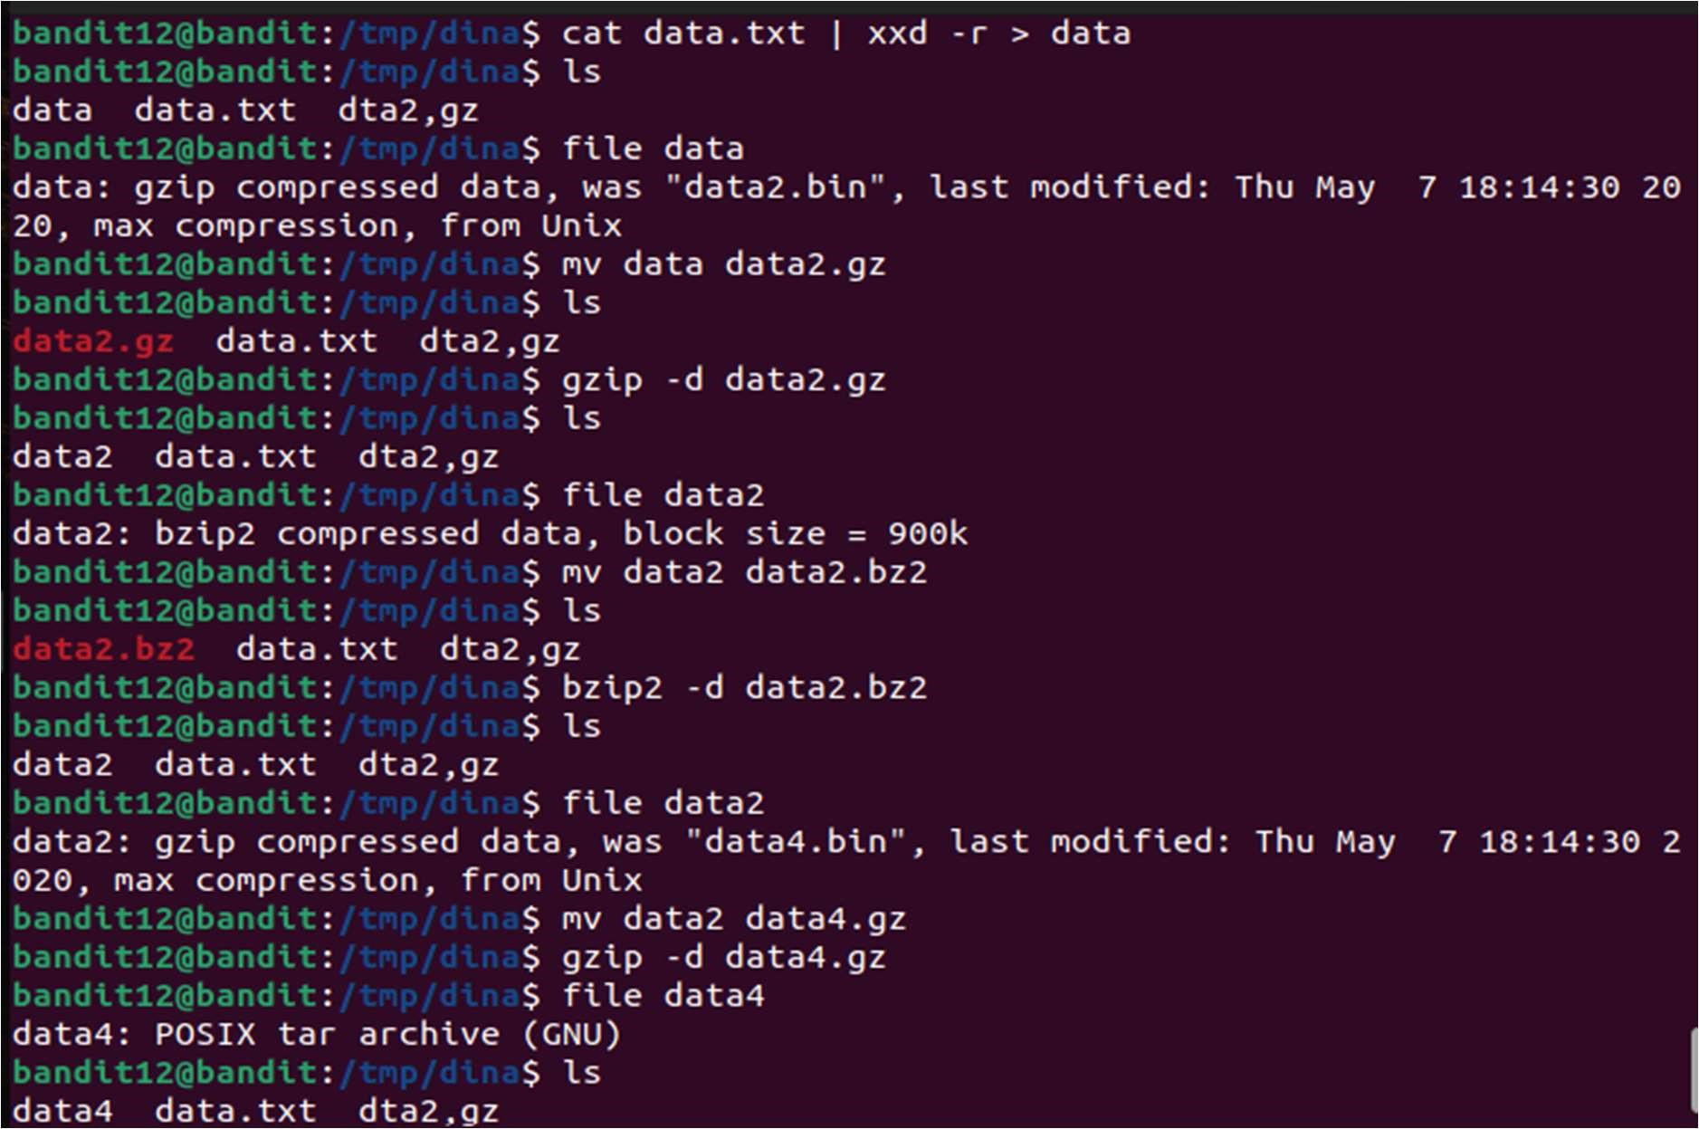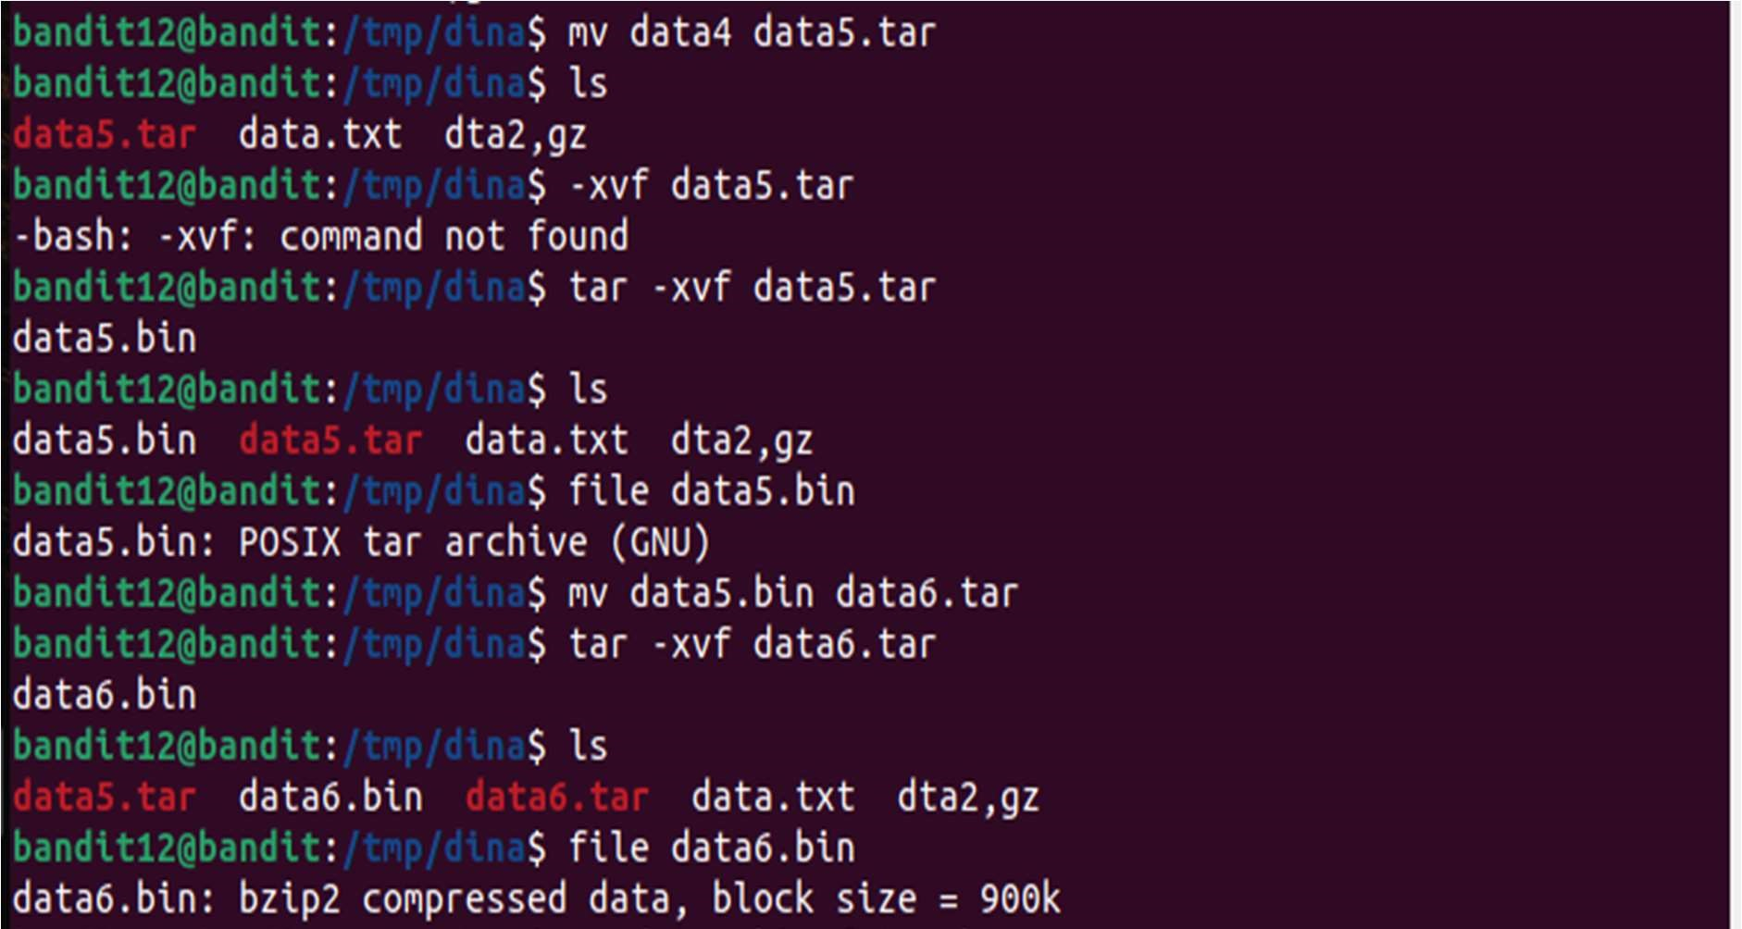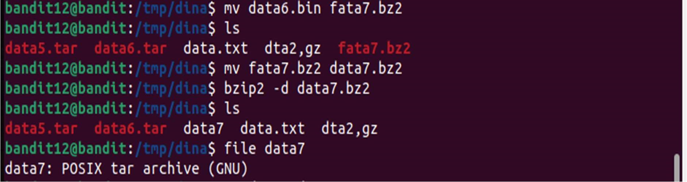

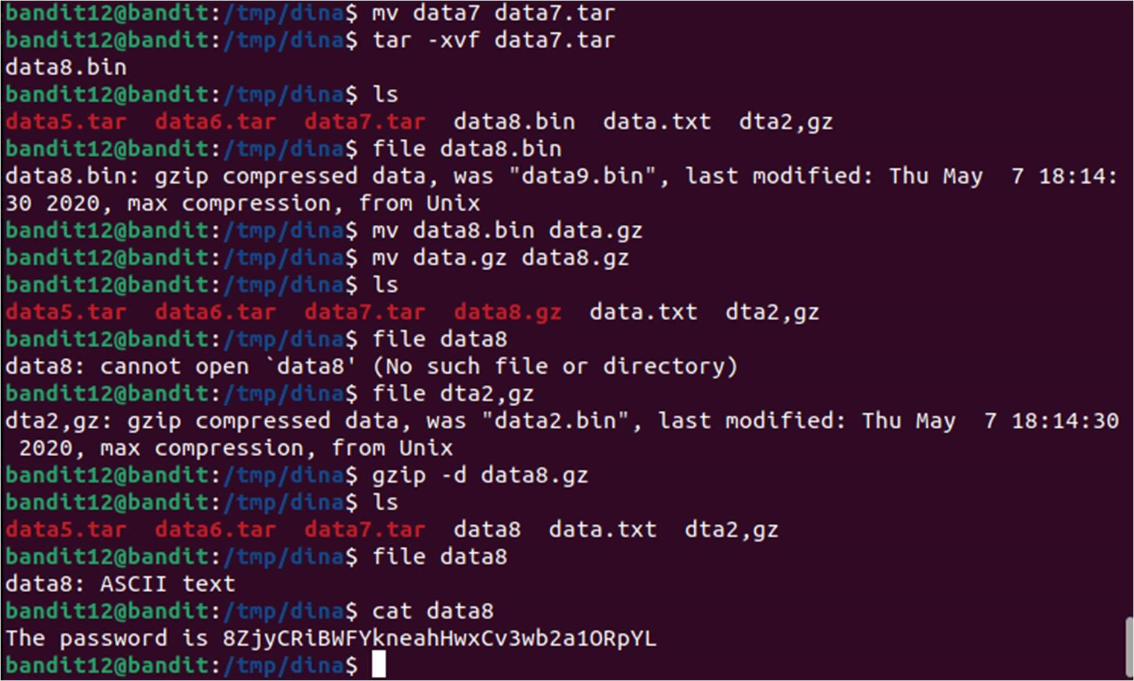

LEVEL 13

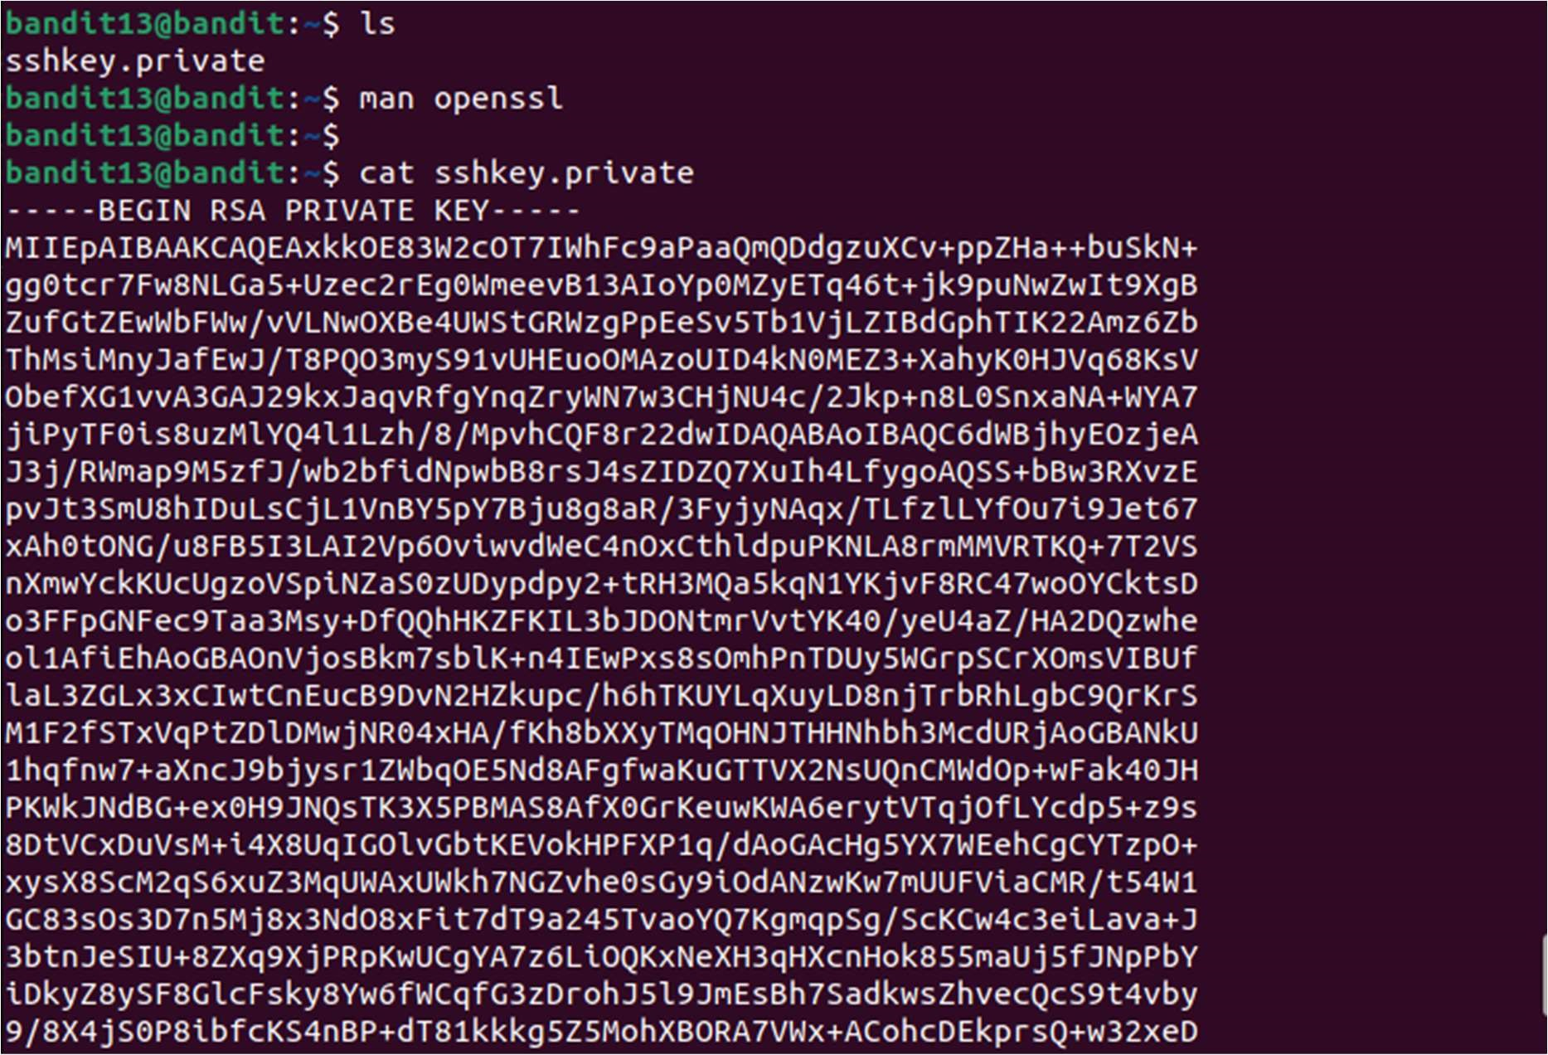

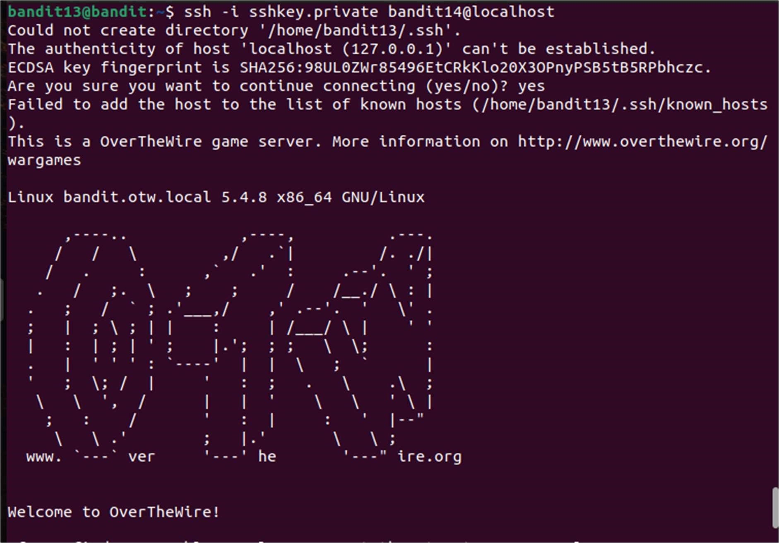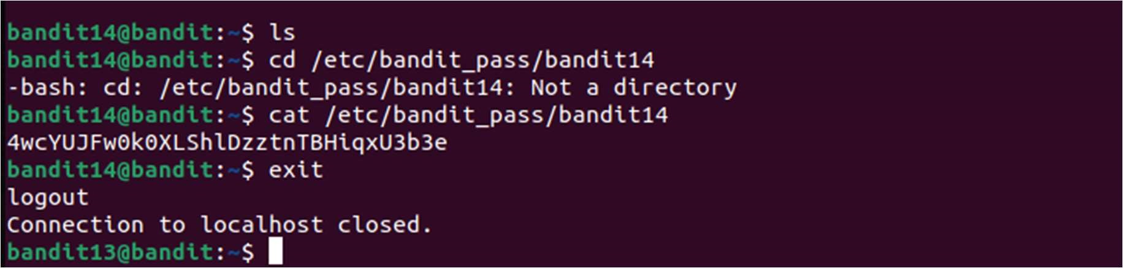

LEVEL 14

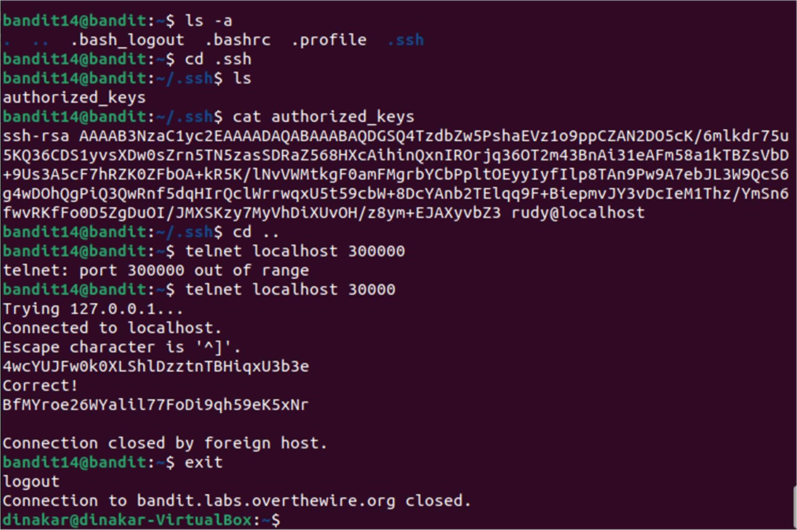

LEVEL 15

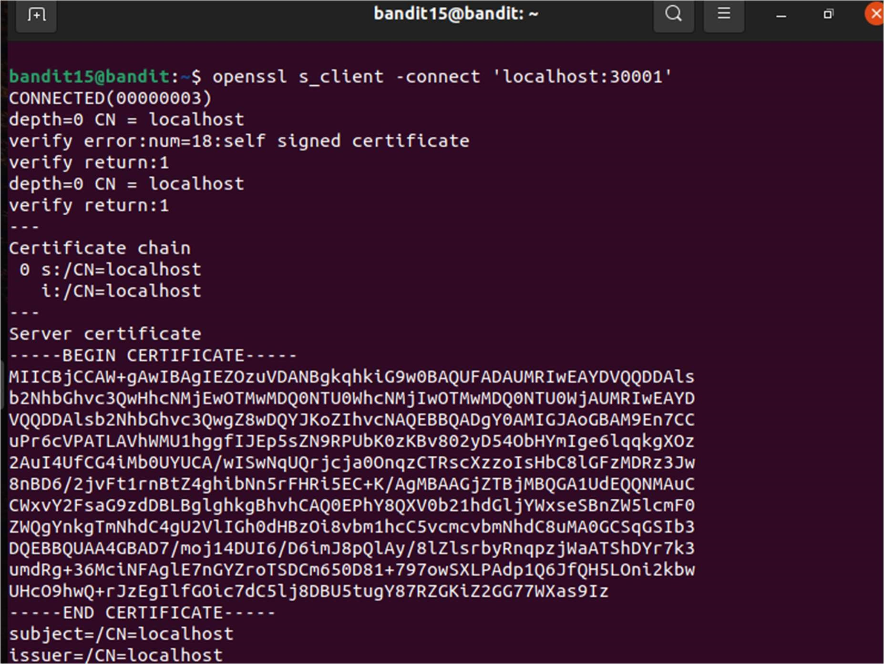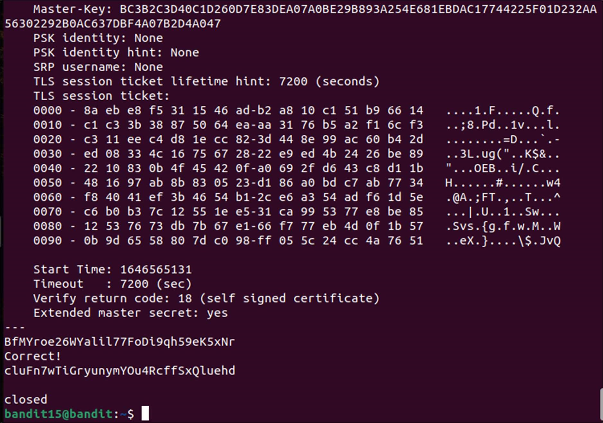

PASSWORDS FOR ALL LEVEL 0-15

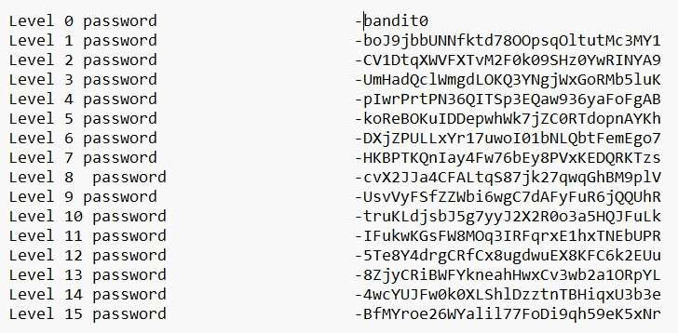

Level 0 password - bandit0

Level 1password-

boJ9jbbUNNfktd78OOpsqOltutM3MY1

Level 2 password - CV1DtqXWVFXTvM2F0k09SHz0YwRINYA9

Level 3 password UmHadQclWmgdLOKQ3YNgjWxGoRMb5luK

Level 4 password pIwrPrtPN36QITSp3EQaw936yaFoFgAB

Level 5 password koReBOKuIDDepwhWk7jZC0RTdopnAYKh

Level 6 password DXjZPULLxYr17uwoI01bNLQbtFemEgo7

Level 7 password HKBPTKQnIay4Fw76bEy8PVxKEDQRKTzs

Level 8 password cvX2JJa4CFALtqS87jk27qwqGhBM9plV

Level 9 password UsvVyFSfZZWbi6wgC7dAFyFuR6jQQUhR

Level 10 password truKLdjsbJ5g7yyJ2X2R0o3a5HQJFuLk

Level 11 password IFukwKGsFW8MOq3IRFqrxE1hxTNEbUPR

Level 12 password 5Te8Y4drgCRfCx8ugdwuEX8KFC6k2EUu

Level 13 password 8ZjyCRiBWFYkneahHwxCv3wb2a1ORpYL

Level 14 password 4wcYUJFw0k0XLShlDzztnTBHiqxU3b3e

Level 15 password BfMYroe26WYalil77FoDi9qh59eK5xNr